NEW Office 365 Email Instructions – Web Access aka “OWA”

Navigate to: https://outlook.office.com/owa - link will also be on our District website.

Enter your username: username@agasd.org (Note: this may NOT be the same as your email address – it will be whatever you used with the old system without the “agsd\”)
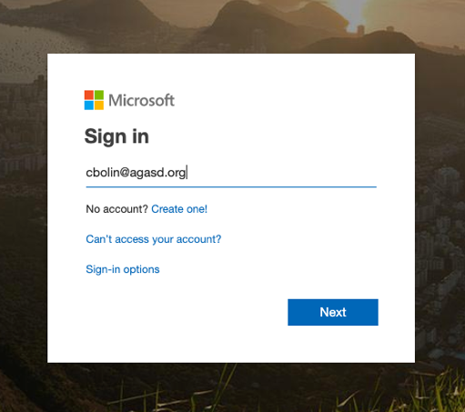
Select “Work or School Account”
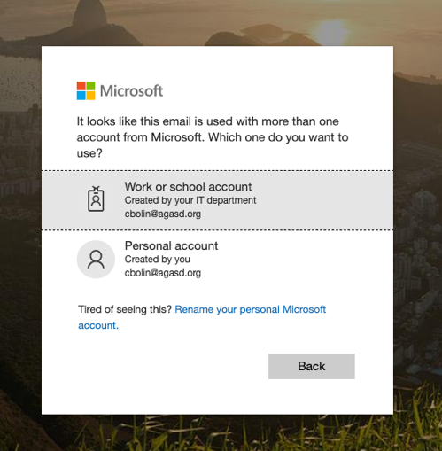

Enter your password (will be same as before) and click “Sign In”
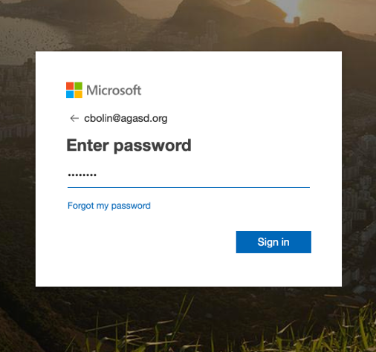

Voila! You are in!

